Carrying out the experiments

A

(i)
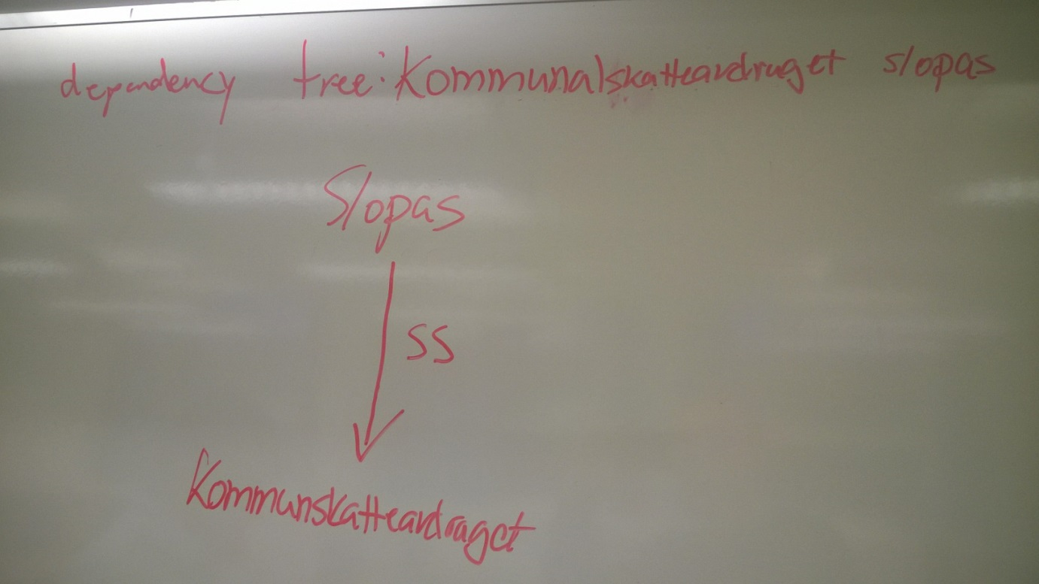
- It doesn’t do a great job on this tree. It only clones its nodes but doesn’t do the rest of the algorithm. There is no Suffix, and it doesn’t change the node into constituent node or adds the node_clone to the originally node. Maybe Slopa(s) is the suffix here.
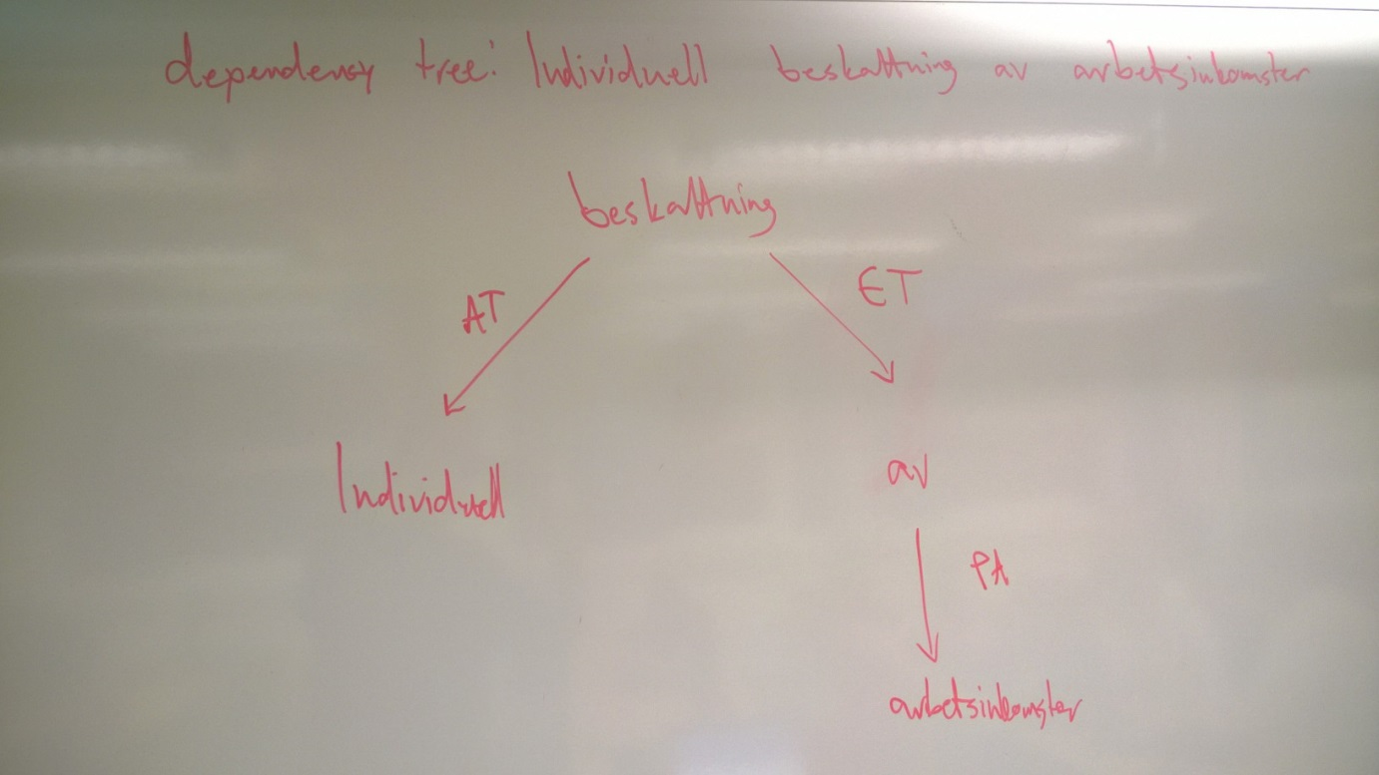
- Same here as in A. It only does part of the algorithm, not whole of it.

(ii)

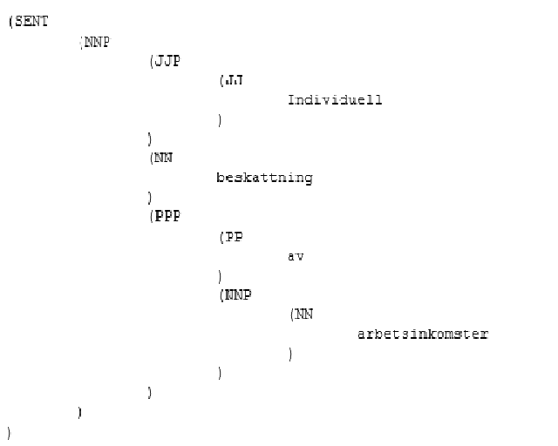
- The algorithm over here doesn’t do the work well. It creates node_clone of the existing node and adds it to the children of the node. But doesn’t do the rest of the algorithm.
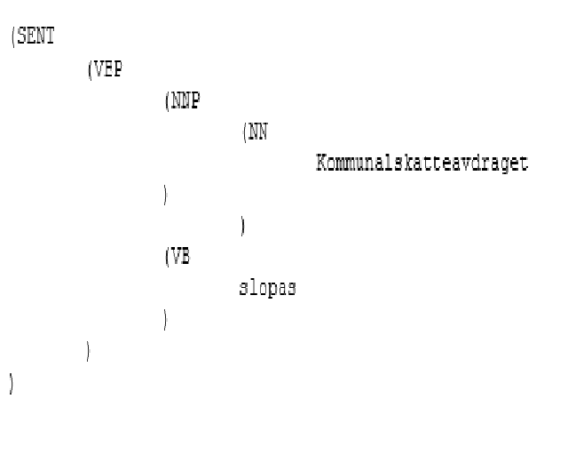
- See answer A.

(iii)

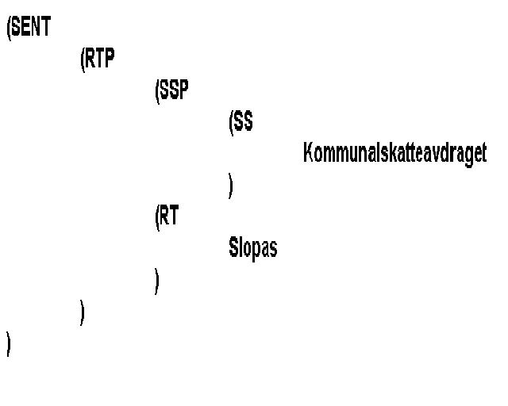
- Look on the answers above. It doesn’t do the job well here also.

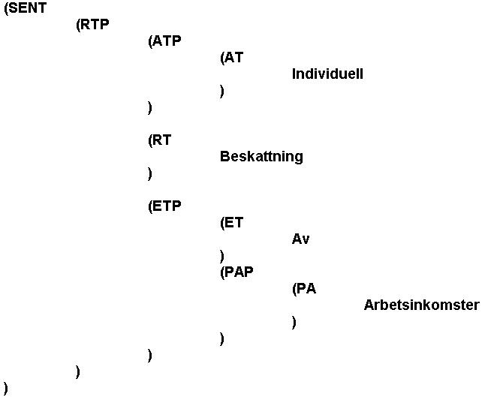
- Look answer A.

B
It depends on where you want the improvement. But if it is in the algorithm, the only thing I can figure is that instead of cloning the node, you can add another node to the existing to create the sentence. Otherwise I cant come up with another solution or improvement.

Parser model dep we find 4489 grammar rules and 13262 lexicon rules. For parsing model post we find 3373 grammar rules and 13195 lexicon rules.

- The phrase structure trees contained in dep apply more tags in each sentence. The trees contained in dep will describe more constiution tags etc..

Bitpar is able to parse a lot of sentences we are sending in through the infile/test-input-testfile. The infile contains words which the extracted grammar/lexicon file cant describe.

